REIT-Based Property Return Indices:
A New Way to Track and Trade Commercial Real Estate

Prepared for the 2009 Real Estate Special Issue of the Journal of Portfolio Management

Holly Horrigan, Brad Case, David Geltner, Henry O. Pollakowski

Holly Horrigan Brad Case
HTHorr@MIT.edu BCase@NAREIT.com
Research Associate V.P. of Research & Industry Information
MIT Center for Real Estate National Association of Real Estate Investment Trusts®
77 Massachusetts Avenue, W31-310 1875 I Street, NW, Suite 600
Cambridge, Massachusetts 02139 Washington, D. C. 20006
T: 617-253-4373 T: 202-739-9400
F: 617-258-6991 F: 202-739-9449

David Geltner* Henry Pollakowski
DGeltner@MIT.edu pollak@MIT.edu
Macomber Professor of Real Estate Finance Principal Research Associate
MIT Center for Real Estate MIT Center for Real Estate
77 Massachusetts Ave., W31-310 77 Massachusetts Ave., W31-310
Cambridge, MA 02139 Cambridge, MA 02139
T: 617-253-4373 T: 617-253-4373
F: 617-258-6991 F: 617-258-6991

*Contact author.

We would like to thank: Brandon Benjamin, John Barwick, Maxx Mantooth and the support of everyone at NAREIT; Schery Bokhari, Dan Kim and everyone at MIT’s CRE, with special thanks to David Hutchings for excellent research assistance.

Abstract

The number of commercial property equity assets that are being held by publicly traded securitized real estate companies, known as Real Estate Investment Trusts (REITS) has increased substantially since the early 1990’s. Many practitioners in the investment industry, as well as academic economists, regard public stock exchanges to be more efficient and liquid than the traditional private property search markets in which whole real estate assets trade directly in privately negotiated transactions. However, it has been cumbersome to fully utilize REITs’ liquidity to make targeted property segment investments because of REITs’ diversification and leverage.
Using REIT return data, bond data, and property holding data, we construct property market segment-specific indices of asset returns. We show that these “pureplay” indices can be employed to make pure, targeted investments in the commercial real estate market while retaining the liquidity, transparency, and pricing efficiency benefits of the well-developed public market in REITs. These pureplay indices compare favorably with existing property market return indices, displaying volatilities similar to transaction-based indices such as the Moody’s/REAL CPPI, but tending to lead the private market in time. The pureplay indices can be generated at a daily frequency without significant noise and at various levels of market segment granularity. The pureplay indices notably have led the transactions-based direct property market indices during the recent market downturn. We suggest that the REIT-based pureplay indices may provide a unique, new information source about the commercial property market, as well as a unique capability to facilitate targeted investments, construct hedges, and to potentially support derivatives trading.

REITs are a means of real estate investment that provide good liquidity and good transparency. While REIT equity values were pummeled during the recent downturn (in a manner understandably exaggerated by REIT leverage), REIT stocks have nevertheless maintained their liquidity and transparency. Whatever the stock market’s weaknesses regarding “herd behavior” and excess volatility, the public securities exchanges are highly efficient information aggregation and price discovery mechanisms. These beneficial characteristics allow us to infer price movements in underlying property markets on a daily basis from REIT returns without having to directly observe property transactions, which occur only with varying frequency and among dissimilar assets.

REITs pose some difficulties for investors and hedgers wishing to trade in commercial property markets, however. On the right-hand side of the balance sheet, almost all REITs are levered. On the left-hand side, almost all REITs’ asset holdings are diversified across individual commercial property market segments, especially across national and international regions. The result is some degree of obfuscation between the property level of the direct real estate market segments and the returns visible directly in REIT stocks or sectors. This article reports on a major effort, sponsored by NAREIT and undertaken at the MIT Center for Real Estate, to develop tradable REIT-based portfolios whose returns reflect unlevered, property-level returns within individual property market segments that are defined by property usage type sector and geographic region. These so-called “pureplay” portfolios can be useful both as information sources about property markets and potentially as tradable portfolios to enable liquid, transparent investment in property market segment-specific portfolios.
Background
The approach presented here of combining information on REIT asset holdings with REIT stock returns to derive information about the underlying property markets dates back, in part, to at least the mid-1990s with work by Giliberto [1993], Gyourko & Nelling [1996], and Geltner & Kluger [1995, 1998]. The last authors originally proposed two methodologies for constructing property return indices using REIT data. Geltner and Kluger [1995] offered a regression based approach wherein REIT returns are “delevered” and regressed against property holding data in a pooled regression. Data limitations at the time of their analysis prevented the construction of a high frequency index. With the benefits of new, larger datasets, we refine and extend their analysis. We show that it is possible to create good-quality, high-frequency indices of property prices using REIT data.
Geltner and Kluger [1998] offered a second approach: the “pureplay” methodology. This approach constructed long/short combination portfolios with “pure” exposures to target real estate segments using mathematical optimization. The pureplay approach also yielded promising results but, again, a high frequency index could not be well-constructed due to limited data availability at the time. In this paper we compare the pureplay methodology with the regression methodology and show that, under conventional assumptions, the two methodologies yield mathematically identical results. In 2008, NAREIT and the MIT Center for Real Estate launched a project to revive and reexamine the pureplay index idea with the aim of developing a commercially useful information and trading product, taking advantage of the rich REIT industry data now available and the considerable growth and development of the REIT industry since the mid-1990s.

The Mechanics: How the Pureplay Portfolios Work
As noted, from a mathematical perspective there are two essentially identical approaches to using REIT returns to construct property asset market segment-specific returns: the regression model and the long/short hedge portfolio. Here we will present the regression perspective, leaving to the Appendix the discussion of the equivalence of the two approaches. We examine property-segment indices at the monthly and daily frequencies and compare them historically to the Moody’s/REAL Commercial Property Price Indices, the leading transactions price based indices of U.S. commercial property price movements in the direct private asset markets.
We employ a modified version of the Geltner-Kluger model in which we regress the contemporaneous monthly REIT returns on a set of variables that represent proportional property segment holdings for each REIT. For a capital return index, the dependent variable is the REIT price return delevered using the Weighted Average Cost of Capital (WACC) accounting identity:
(1)
Rather than pooling observations as in Geltner and Kluger [1995], greater REIT data availability now allows us to perform a separate regression for each period (monthly or daily) over the period January 1, 2001 to December 31, 2007.
Therefore, the delevered return for REIT i is regressed on its asset holding exposures to each property market segment.:
(2)
where roa_{i,t} is REIT i’s delevered return over the period t-1 to t; the x’s refer to REIT i’s percentage of total assets held in each segment at t-1; the b’s are the market-segment index returns; the subscripts: A, I, O, R, and H refer to apartment, industrial, office, retail, and hotel market segments, respectively, and :
x_{Ai,t} + x_{O,i,t}+ x_{I,i,t} + x_{R,i,t} + x_{H,i,t = 1} (3)
Rewriting in matrix notation, we have (omitting the subscript t for clarity):
roa = Xb + u (4)
where roa is a vector of length N, with each element representing the period t-1 to t return to each of the i=1...N REITs. X is an NxK matrix containing the dollar percentages of assets held by each REIT in each of the k=1...K segments (in the model described by equation (2), K is the 5th of 5 segments). By increasing the number and specificity of explanatory variables, we can construct indices of greater granularity as we show later on in this paper.
In order to efficiently estimate the segment returns (the regression coefficients), we employ GLS weightings based on an assumption, consistent with Geltner-Kluger, that the variance of each REIT’s idiosyncratic return, e_{i} , is inversely proportional to the total dollar value of its property holdings, and that the idiosyncratic returns are uncorrelated, normally distributed, and have mean zero. Intuitively, this weighting reflects the assumption that larger REITs are likely to have less idiosyncratic return variance because they have less property-level idiosyncratic risk exposure as a result of holding larger, more diversified portfolios of properties. In other words, a type of heteroskedasticity exists in which smaller REITs have greater idiosyncratic variance. We then estimate the indices using generalized least squares:
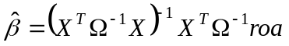 (5)
where Ω is an NxN diagonal matrix containing the idiosyncratic REIT return variances, with each diagonal element defined as:
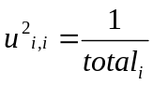 (6)
where total_{i} = total dollar value of properties held by REIT i.
We define a segment portfolio H as follows:
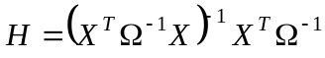 (7)
The matrix H describes a set of weights which define hedge portfolios that eliminate exposure to all but one market segment for each portfolio. That is, H is a KxN matrix where each row k represents a portfolio of weights of REITs having unit exposure (100% exposure) to segment k and zero exposure to every segment other than segment k. The segment portfolio weights, which represent both long and short positions, sum to one for the target segment and to zero for the non-target segments. A segment portfolio, were it investable, would yield a pure return to the target segment while minimizing idiosyncratic REIT return variance.
The segment portfolios contained in H do not include the debt positions needed to offset the leverage held by the REITS, because that leverage has already been removed from the dependent variable (roa). Additionally, notice that the optimal relative weights of the REITs in the segment portfolio H are independent of leverage and the techniques used to deleverage the REIT returns. This implies that, were an investor to purchase the “segment portfolio”, it would be possible to synthetically add or subtract leverage by appropriately scaling the portfolio weights.

Data
We study publically traded equity REITS during the period 2001-2007 using as our universe the REITs listed in the NAREIT/FTSE indices. Exhibit (1) shows the numbers of publically traded equity REITs in each of the NAREIT/FTSE indices during the study period. The decline in publicly traded equity REITS in 2006, 2007 and into 2008 is caused both by consolidation within the REIT industry and by a flurry of privatizations.
Using information supplied by NAREIT along with data pulled from public SEC 10k filings, we calculate the explanatory variables needed for the models for each month. For example, Exhibit (2) shows the distributions of the exposures (denoted exp) to the office sector for the first and last years in our study period.
Where the dollar value of assets in a REIT’s portfolio is unknown, proxies for property value such as rental income or total square footage are used to calculate the percentage holdings in the various market segments. Few REITs diversify equally across industries. It is unusual to find a REIT with 25% of its holdings in apartment, 25% in industrial, 25% in retail, etc. However, many REITs have some small exposure to sectors outside their primary type. Of the sectors examined, hotel/lodging REITs tend to be the most highly focused.
Exhibit (2) is typical and shows that classifying REITs into property sector categories without accounting for smaller segment holdings ignores a good deal of valuable information. The regression model presented here is able to utilize all of the property holding information -- even the smallest exposures. By contrast, the NAREIT/FTSE sector indices would categorize a REIT whose retail properties comprise 60% of its portfolio as excluded from the retail sector index despite the fact that the majority of its property exposure is in the retail sector. (As noted, this convention applies to all of the NAREIT/FTSE indices.)
Using the same property holding data, we can similarly generate independent variables for a twenty-segment model consisting of the five property sectors times four geographic regions. As we discuss later in the results portion of the paper, a few segments must be recombined in order to create stable regression estimates. For example, regional hotel segments are not well represented in the data in the early years of the study and are recombined.
Return data for the REITs was supplied by NAREIT. We utilize price-only returns (excluding dividends), so as to track property price movements. Returns were reviewed for data errors but none needed to be culled or truncated.
Using financial information from NAREIT and from annual 10k forms, we generate values for the %equity_{i,t} and the (1-%equity_{i,t} ) terms of equation (1), for each REIT and time period. The %equity (also referred to as the equity ratio) is defined as total stockholder’s equity, as reported on the REITs’ 10k forms, divided by the sum of total stockholder’s equity and total liability. The equity ratio data is updated annually for each year in the study. We do not adjust for possible minority interest holdings because, during the study period, minority interests were relatively insignificant on most balance sheets. In the future, minority interests may become more significant on a greater number of the REITs’ balance sheets and would therefore warrant closer attention. Equity ratios remained fairly stable during this period with a mean and median of 36% in 2001 and 2007 and a cross-sectional range from 7% to 83% in 2001 and from 7% to 76% in 2007.
Referring again to equation (1), we need an estimate for the cost of debt (debtrate) in order to complete the deleverage calculation. Pagliari, Scherer, & Monopoli [2005] proposed estimating the cost of debt as a function of interest expense, preferred dividends, value of preferred shares, and debt. In this paper, we use market-wide average yields on unsecured REIT debt as a proxy for the cost of debt, with the same rate applied to every REIT for the year. Some REITs report their weighted average cost of debt in their annual 10k filings. A comparison of the REIT-reported average costs of debt with the estimated values in Exhibit (3) indicates that our estimates are reasonable. For example, in 2007, Boston Properties reported a weighted average cost of debt of 5.60%. Mack-Cali Realty reported a value of 6.08%. The model uses a value of 5.66% in 2007 for all REITs. While the deleveraging process would be more precise if REIT-specific values were obtained, we defer this refinement for future research. As mentioned in the previous section of this paper, assumptions regarding cost of debt can be varied without changing the composition of the segment portfolios defined by equation (7).

Results
We begin by running the GLS regressions described by equation (2) separately for each of the eighty four months spanning 2001-2007. We accumulate the estimated segment returns defined by equation (5) and plot them against the corresponding quarterly or annual Moody’s/REAL CPPI index which tracks the private market transaction prices directly. As illustrative examples, exhibits (4)-(5) plot the indices for the Apartment and Office sectors. The similarity between the REIT-based and private market based price indices suggests that the REIT-based indices are indeed capturing the essence of the segment-specific returns to the underlying private property market, but with some interesting differences, as described below.
For each sector except apartment/residential, the REIT-based estimated delevered segment returns resemble the corresponding Moody’s/REAL price changes. Of course we would not expect the two types of indices to be identical, as they are not tracking exactly the same property markets and the stock market does not evaluate property in exactly the same way that the private direct market does. Furthermore, the REIT-based indices may reflect effects of REIT-level management or a market-wide REIT discount or premium. Perhaps most interesting is the apparent ability of the REIT-based indices to lead the private market price movements. For example, the REIT-based Office index shown in Exhibit (5) begins to decline in January 2007, whereas the Moody’s/REAL suggests that prices in the private market did not begin to decline until after the following June.
The difference noticeable in Exhibit (4) between the REIT-based index and the private market based index in the Apartment sector is logically attributable to the difference in condo conversion participation during this time period, with REITs being less active in this market than private investors. Exhibit (6) highlights the spike in private-market condo conversions beginning in 2003/2004 and declining after 2005. During 2004-05, condo conversion demand drove up the prices of apartment property transactions in the private market broadly as landlords sold out to converters. But apartment REITs were generally committed to remaining permanently in the apartment rental business and the stock market knew that. Hence, apartment REIT share prices were not bid up in anticipation of “flipping” apartments to condo-converters. The REIT-based apartment index therefore continued to reflect more fundamental valuations of apartments as rental units, unlike many transactions in the direct private property market. By late 2005 and 2006, the condo boom came to an abrupt end, causing the drop in prices in the private market reflected in the Moody’s/REAL index during that period, while the REIT-based valuations continued to rise steadily. The last surge in the private equity and CMBS-based boom in the private property market was reflected in the Moody’s/REAL Index upsurge from late 2006 through mid-2007, whereas the REIT-based apartment index began its downturn in January 2007, anticipating the subsequent private market correction.
Exhibit (7) compares the annualized volatilities of the REIT-based pureplay indices with the Moody’s/REAL indices over the same period. The pureplay volatilities are similar to (in some cases lower than) the volatilities of the corresponding transaction based private market indices.
Experimenting with Model Granularity
Across industry segments, the Pureplay indices resemble delevered NAREIT indices while offering modest improvement in volatility. A more significant contribution of the Pureplay methodology lies in its ability to provide granularity across industry segments and regions simultaneously. Therefore, we explore the feasibility of using both property usage type sectors and geographic location information together to further refine market segments. To do this, we expand the number of independent variables in the regressions from five to twenty, reflecting five sectors times four regions. Of course, the inclusion of twenty explanatory variables can cause high standard errors in the estimated segment returns due to the multicollinearity of a few of the exposure variables. In order to quantify and mitigate the severity of this multicollinearity, we calculate variance inflation factors (VIFs).
For each month over the period 2001-2007, we regress each market segment variable on all remaining market segment variables and calculate VIFs. We average the 84 period VIFs to get an average VIF for each explanatory variable. Using this VIF analysis, along with simple correlations between variables, we analyze how best to combine regions so as to retain as much granularity as possible. We combine the hotel market segments into a single nearly-orthogonal independent variable. We also combine Industrial South and Industrial West. The resulting VIFs in the 16-segment model are much lower for the combined segments and are low and mostly unchanged for the remaining segments (VIFs of 2.00 or lower). Only the Industrial Midwest segment remains possibly problematical. It is important to remark that the VIFs for the regional Hotel market segments drop significantly between 2001 and 2007. In fact, by 2006, the regional Hotel VIFs are all 2.00 or lower as a result of increased REIT participation in the Hotel market segment. In the future, it may be possible to disaggregate the Hotel segments. In contrast, the VIFs for Southern Industrials and Western Industrials remain stable and elevated over the period. Given the limitations of the data, at this time we are unable to explore market segments such as economic/metropolitan regions. However, our early investigations suggest that with additional data, further segmentation will be possible and valuable.
Exhibit (8) shows the graphs for the delevered industrial east, midwest, and south/west model alongside the corresponding Moody’s/REAL CPPI Indices (where available) and the national sector index previously reported. Exhibit (8) highlights the difference in regional performance within the industrial property sector during 2001-07. The difference in cumulative return performance between Southern/Western industrials and Midwestern Industrials is over 130%. Other sectors show less regional differentiaion. For example, in the Retail sector the West Coast outperformed the East Coast by 35% over the seven years. In general, the Moody’s/REAL indices do not reflect as much regional differentiation as the REIT-based indices over this period.
Daily-frequency Property Sector Indices
Beginning in 2004, we generate the national sector indices on a daily basis. We have not yet been able to update property portfolio holdings or balance sheet data on a daily basis for this study, but we observe little change in overall proportional holdings over time, even on a quarterly basis. Daily returns for REITs are readily available. Exhibit (9) shows the estimated indices for the Industrial sector on a daily basis, on a monthly basis and as compared to the quarterly Moody’s/REAL CPPI
. It is interesting to notice that increasing the estimation frequency from monthly to daily does not introduce additional noise into the estimated indices. This is confirmed visually by the graphical comparison of the daily and monthly indices, and statistically in Exhibit (10) which provides a comparison of volatilities of the indices. This type of increasing frequency without increasing noise or lag is only possible with a stock market based index because of the informational efficiency of daily stock market closing prices. There is relatively little random price level dispersion or “noise” in stock prices compared to individual private market transactions of individual properties.

The Role of Pureplays in Portfolio Investment Strategy

The pureplay portfolios presented here are of interest as information tools to empirically track price movements and investment returns in property market segments. However, they potentially go beyond merely providing useful information to the marketplace. These indices present interesting possibilities for supporting derivatives and investment vehicles for synthetic or indirect investment in commercial property. Recently, trading of derivatives based on private market indices of commercial property returns has significantly taken off in the UK, where the notional value of swaps traded based on the (appraisal-based) IPD Index has recently grown to approximately one-half the cash trading volume in the physical properties tracked by the index. Synthetic real estate investment vehicles offer certain features such as low transactions and management costs, relatively less management burden, easy diversification across individual properties, and the ability to sell short (which enables hedging of real estate market risk exposures and the harvesting of “portable alpha”).

The pureplay indices presented in this paper may support commercial property derivatives and synthetic or indirect property investment in several new ways. First, as we have seen, the public market tends to lead the private market indices in time, so the pureplay indices contemporaneously reflect the relevant price discovery in each property market segment. Second, the pureplay indices can be produced at a high frequency without loss of accuracy. For example, daily-updated indices can be easily produced using daily REIT share closing prices. Frequent updating can be useful in derivatives markets as it allows frequent marking-to-market of the values of the derivative contracts, which in turn minimizes required margin positions. Third, unlike private market based indices where it is not possible to actually buy and sell the underlying properties, the pureplay portfolios can in principle be directly constructed and traded via long and short positions taken in the publicly-traded REITs that compose the portfolios. This facilitates pricing of derivatives (as it renders more meaningful the use of traditional arbitrage-based pricing formulae), and it also enables construction of exchange-traded funds (ETFs) or other such funded vehicles that track or implement the pureplay indices. This helps to address the “counter-party problem” which can make it difficult to get a liquid derivatives market established. In effect, the liquidity in the stock market can be used to provide the necessary counter-parties to the derivative transactions.

Conclusions
Using REIT return data, property holdings data, and REIT financial information, it is possible to construct REIT-based pureplay indices (or portfolios) with unit exposure to a desired property market segment, zero exposure to all other property market segments, and minimum idiosyncratic risk. Additionally, with financial data about REIT debt and equity holdings along with information about the cost of REIT debt, it is possible to adjust for REIT leverage and to generate estimated market segment returns for the underlying property market using the segment portfolio weights. These estimated market segment returns, or indices, provide new and valuable information about the underlying property markets on a high-frequency, temporally-leading basis. In this paper, we demonstrate by comparison to the Moody’s/REAL indices that a 16-segment model provides good granularity with high frequency potential.
An important contribution of the type of indices described herein lies in their application to support derivative trading and synthetic investment in the commercial property market. Higher-frequency indices enable lower margin requirements for derivative products such as swaps. Because REIT-based indices lead private-market based indices, they are a natural basis for derivate products. The tradeable underlying market segment portfolios enable arbitrage execution between the derivative and the underlying, facilitating pricing in the derivative market, providing profit opportunity for traders, and therefore promoting liquidity in the derivatives market. Starting from the market segment portfolio weights, sophisticated users can synthetically construct targeted or balanced portfolios and synthetically add or subtract leverage as desired
Appendix:
Demonstration of Equivalence of the Regression and Long/Short “Pureplay” Portfolio Approaches

Consider how the regression-based approach to property segment-specific index identification using REIT returns represented by equations (1) through (7) effectively implements the so-called “pureplay portfolio” approach described in Geltner & Kluger [1998]. Using Geltner-Kluger notation:
(8)
where:
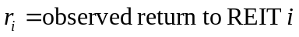
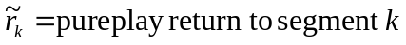
and again:
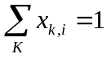
where K denotes the last of some number of segments. Note that equation (8) looks very similar to equation (2) except for the specification of the error terms (the idiosyncratic returns).
Geltner-Kluger assumes that the idiosyncratic components are random, uncorrelated with each other, and have mean zero. Define a pureplay portfolio as a portfolio with unit exposure to the desired segment and zero exposure to all other segments:
(9)
where each w_{i} equals the percentage of the portfolio’s holdings in REIT i and where the constraints for a pureplay portfolio for a single segment k can be written mathematically as:
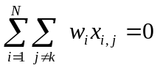 (10a)
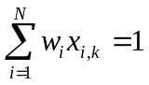 (10b)
Substituting the constraints (10) into equation (9) yields a simplified equation for the return to the pureplay portfolio for segment k:
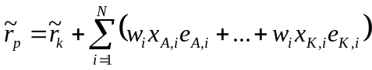 (11)
the variance of which is given by:
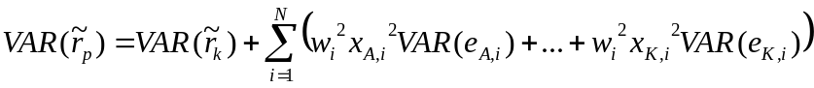 (12)
In Geltner and Kluger [1998], the authors assume that the idiosyncratic segment variance is inversely proportional to a REIT’s dollar holdings in that segment (recall that this assumption is similar to, but not identical to, the assumption used in the GLS model, equation (6)). Specifically:
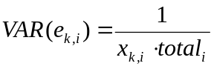 (13)
If we substitute the values from (13) into equation (12), we can simplify the minimization problem somewhat more:
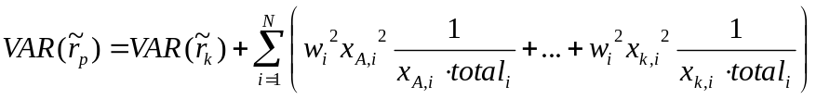 (14)
which reduces to:
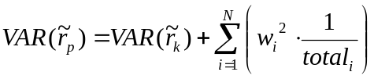 (15)
As we differentiate equation (15) with respect to the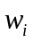for the purposes of minimization, it becomes clear that the solution is a function of just the second term.
Because of our assumptions regarding idiosyncratic returns, the variance of the idiosyncratic returns in the pureplay model reduces to the same variance assumption used in our GLS regression models. Recall that the estimated GLS coefficient vector minimizes the sum of the squared errors of the regression. In other words, it minimizes the variance of the error terms (the idiosyncratic returns). In the case of the GLS regression models, these variances are assumed values contained in Ω which were defined in equation (6). Therefore, the GLS solution yielding H is identical to the solution to minimizing equation (15) with respect to the w_{i}. As a result, it is not necessary to develop both the regression and the long/short hedge portfolio frameworks under the current set of assumptions and the paper proceeds using the regression framework.
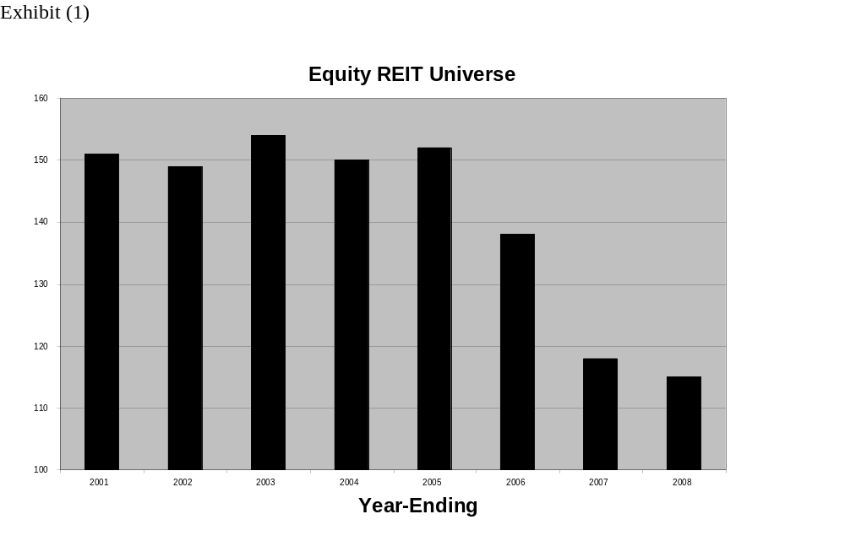Exhibit (2)
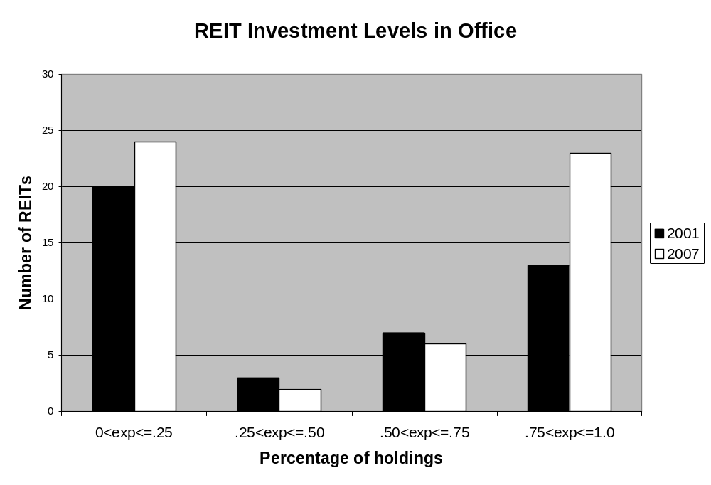

Exhibit (3)

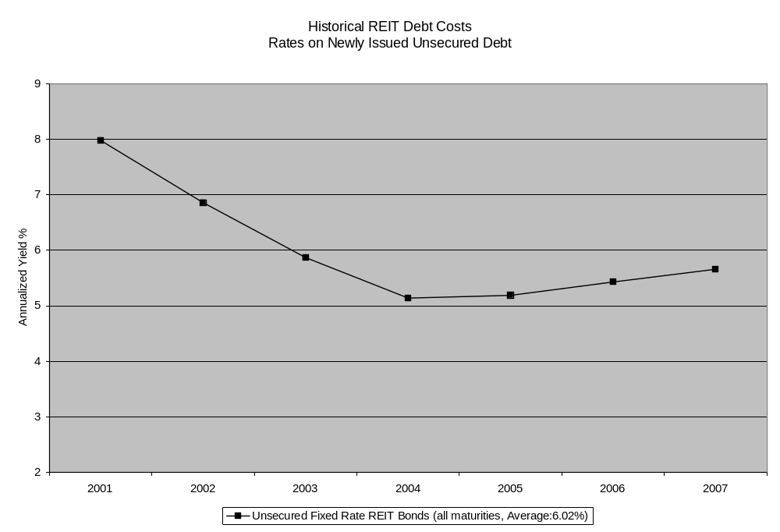

Exhibit (4)
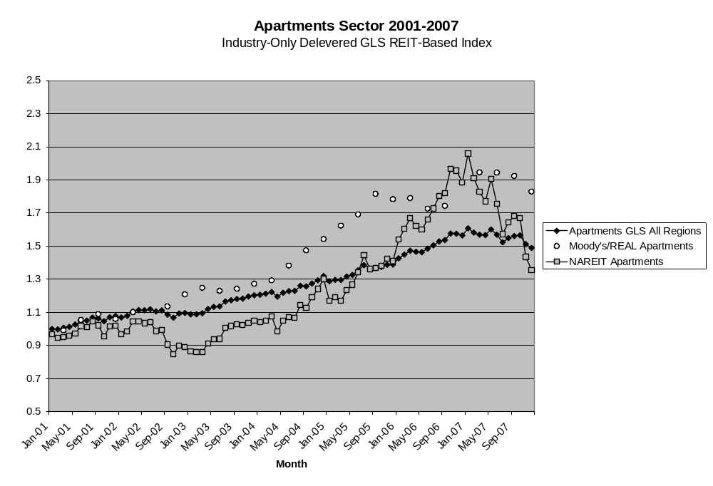

Exhibit (5)
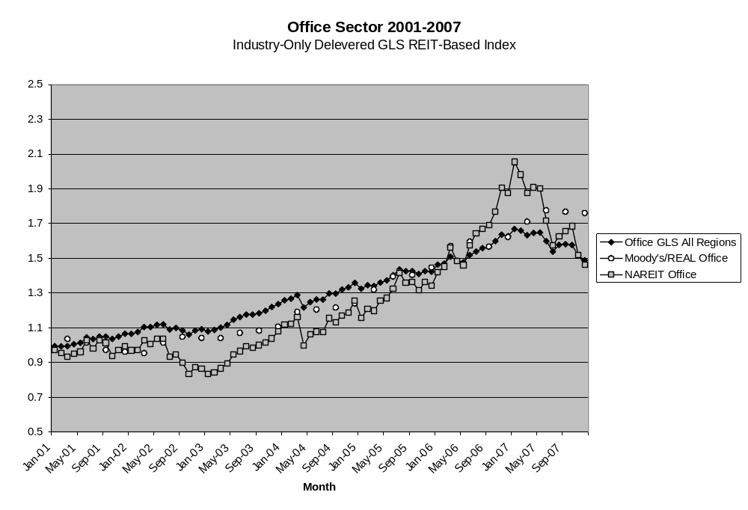

Exhibit (6)
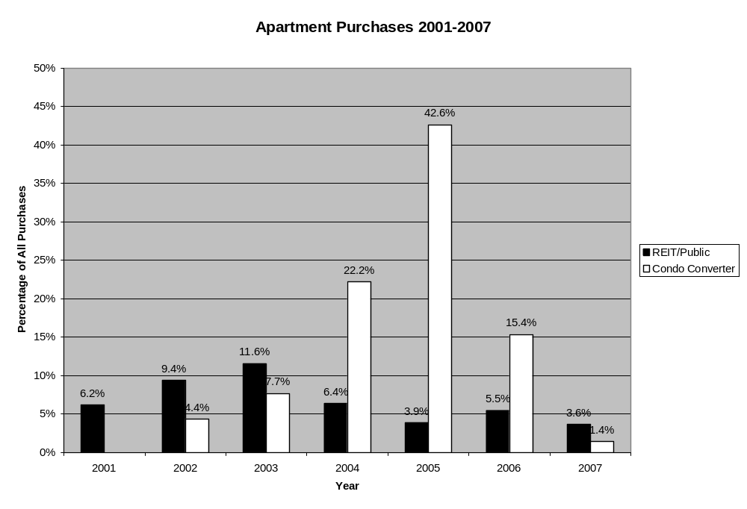

Exhibit (7) Volatility Comparison, 2001-2007:

 | Apt | Office | Indust | Retail | Hotel
REIT-based  Monthly Delevered  Annualized Volatility | 4.80% | 5.84% | 6.46% | 5.18% | 10.15%
Moody’s/REAL Quarterly  Annualized Volatility | 8.06% | 6.27% | 7.05% | 5.11% | N/A

Exhibit (8)
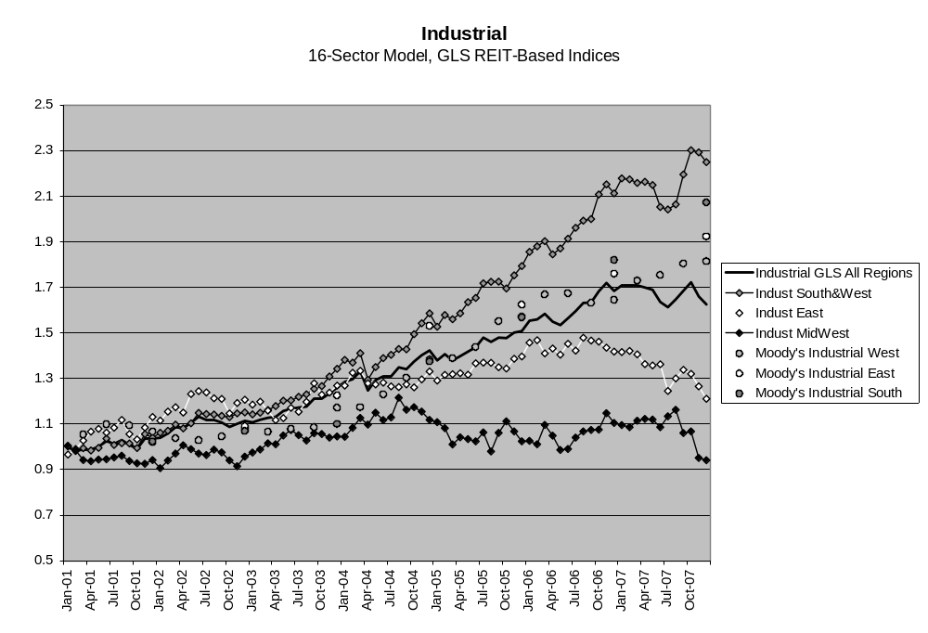

Exhibit (9)
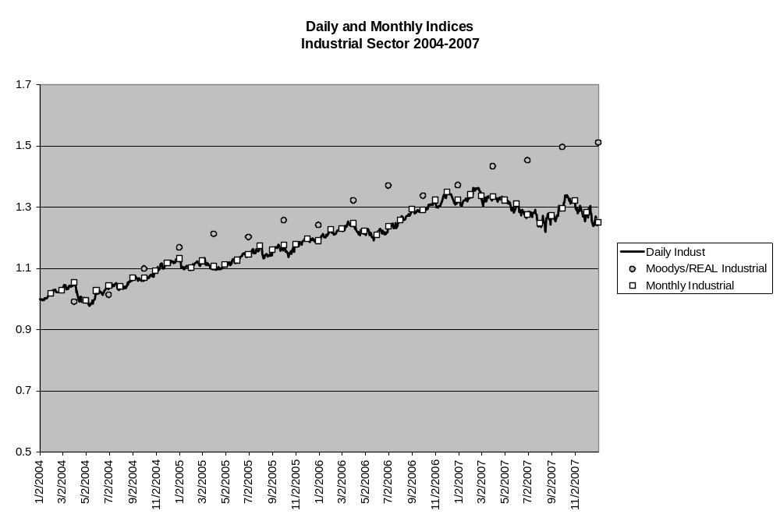

Exhibit (10) Volatility Comparison, 2004-2007:

 | Apart. | Office | Indust. | Retail | Hotel
Daily Model Annualized Volat. | 4.70% | 6.49% | 6.25% | 6.32% | 7.34%
Monthly Model Annualized Volat. | 4.36% | 6.11% | 6.18% | 6.27% | 7.27%
Moody’s/REAL CPPI Quarterly Annualized Volat. | 8.03% | 6.15% | 6.13% | 5.70% | N/A

References

Geltner, Kluger (1996). A regreesion-based Approach to Developing Historical Indices of Commercial Property Returns by Type of Property Based on REIT Share Returns, AREUEA Annual Meeting, January 5-7, 1996.

Geltner, Kluger (1998). REIT-Based Pure-Play Portfolios: The Case of Property Types, Journal of Real Estate Economics V26(4): 581-612.

Giliberto (1993). Measuring Real Estate Returns: The Hedged REIT Index, The Journal of Portfolio Management V19(3): 94-99

Greene (2003). Econometric Analysis 5th Edition, Prentice Hall
Publishers ISBN 0-13-066189-9.

Grinold, Kahn (2000). Active Portfolio Management Second Edition, McGraw-Hill Publishers ISBN 0-07-024882-6.

Gyourko, Nelling (1996). Systematic Risk and Diversification in the Equity REIT Market, Real Estate Economics V24(4): 493-515.

Liang, Chatrath, MacIntosh (1996). Apartment REITs and Apartment Real Estate, The Journal of Real Estate Research V11(3): 277-290

Pagliari, Scherer, Monopoli (2005). Public versus Private Estate Equities: A More Refined, Long-Term Comparison, Real Estate Economics V33: 147-187.

We use the term “segment” to refer to a combination of property usage type sector and geographical region that defines some segment of the overall aggregate commercial property market. From the perspective of institutional investment, the entire commercial property market (all income-producing investable properties) may be viewed as composing the investment “asset class”. However, from the perspective of users of commercial space (the rental market) this aggregate of all property is actually a collection of numerous effectively geographically bounded specific property type markets (such as the Manhattan office market). Many investors in the real estate asset class like to target their investments based on some segmentation related to an understanding of the underlying rental markets. While the REIT-based indices presented here do not get down to the metro area level of granularity, they do provide substantial geographical and usage type segmentation, as we will see.
The Moody’s/REAL Commercial Property Price Index is based on data from Real Capital Analytics and methodology licensed by MIT to Real Estate Analytics LLC (REAL). It is produced and published monthly by Moody’s Investors Service and is downloadable free from Moody’s (www.Moodys.com) or from REAL or MIT/CRE (http://web.mit.edu/cre/research/credl/rca.html).
The Geltner-Kluger 1995 working paper was presented at the 1996 AREUEA Annual Meeting and is available from the authors upon request.
Of course, a total return index is also possible simply by substituting total returns for price returns. In the present model the same debt interest rate is used for each REIT in order to implement the WACC. This could be revised to incorporate unique debt rates at the REIT level. We also created the pureplay indices without delevering REIT returns but the results are not presented in the interest of brevity.
While running a pooled regression can sometimes provide more explanatory power than running separate regressions for each time period, separate regressions have the advantage of avoiding backward revisions in estimated returns, and this can be useful in an index designed to support derivatives trading.
In practice, many REITS have miscellaneous property exposures to segments not included in the model, such as land, garages, or international assets. Based on experimentation, we aggregated the miscellaneous property exposures into a single “other” segment and excluded any REITs having an “other” segment in excess of 30% of total property holdings. When “other” is less than 30% of total holdings, the REIT is included in the regression, the “other” exposure is ignored, and the remaining segment exposures are rescaled to sum to one. The error term correctly captures returns due to these miscellaneous exposures as long as these miscellaneous exposures are not substantially correlated with our included segments.
These assumptions are not necessary to construct our model using regression analysis, but relaxing these assumptions requires additional econometric manipulations not explored within the scope of this paper.
We also explored an alternative assumption, using 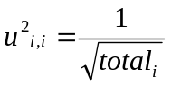as our idiosyncratic variance assumption. These results are not presented here, but we found that in certain circumstances, this formulation may be preferable. However, in most cases, results were insignificantly different.
We checked the validity of this assumption by comparing changes in exposures using various methodologies on REITs for which multiple types of data were available.
As noted previously, the methodology described here could as easily be applied to total returns data, to yield total return property indices. From the perspective of derivatives trading, there is little need for a total return index, as almost all of the volatility in property returns is in the capital component.
Annualized volatility = monthly volatility * sqrt(12) for REIT-based index; quarterly volatility * sqrt(4) for Moody’s/REAL index.
NCREIF indices may have even lower volatility, but they are based on appraisals rather than actual transaction prices. With an appraisal-based index, low volatility suggests a concern about lagging and smoothing in the appraisal and index construction process. However, in the case of a transaction based or stock market based index, artificial lagging and smoothing are not a concern, which means that low volatility is an indication of a good quality index that avoids excess noise or idiosyncratic variance.
Please contact the authors for detailed comparisons between the 5-segment industry pureplay indices and the NAREIT/FTSE indices.
We employ NCREIF’s geographic definitions for West, Midwest, South, and East.
Fundamentally, this is due to insufficient REIT holdings in the case of the Hotel sector. In the Industrial sector, the multicollinearity is caused not by a scarcity of holdings but rather by similar investment patterns across REITs.
For a presentation on Variance Inflation Factors, see, for example, Greene’s Econometric Analysis Fifth Edition., pg. 56-58.
Please contact authors for detail on all sixteen property and region indexes.
In the U.S., trading on the NCREIF Index has been slower to take off, but has been active since mid-2007, with over $2 billion notional value of NPI swaps traded over-the-counter by late 2008. (This is still miniscule compared to direct cash trading in underlying commercial property exceeding $300 billion in the U.S. during 2006, as tracked by Real Capital Analytics.)
as long as we continue to assume the idiosyncratic returns are random, are uncorrelated, and have mean zero

